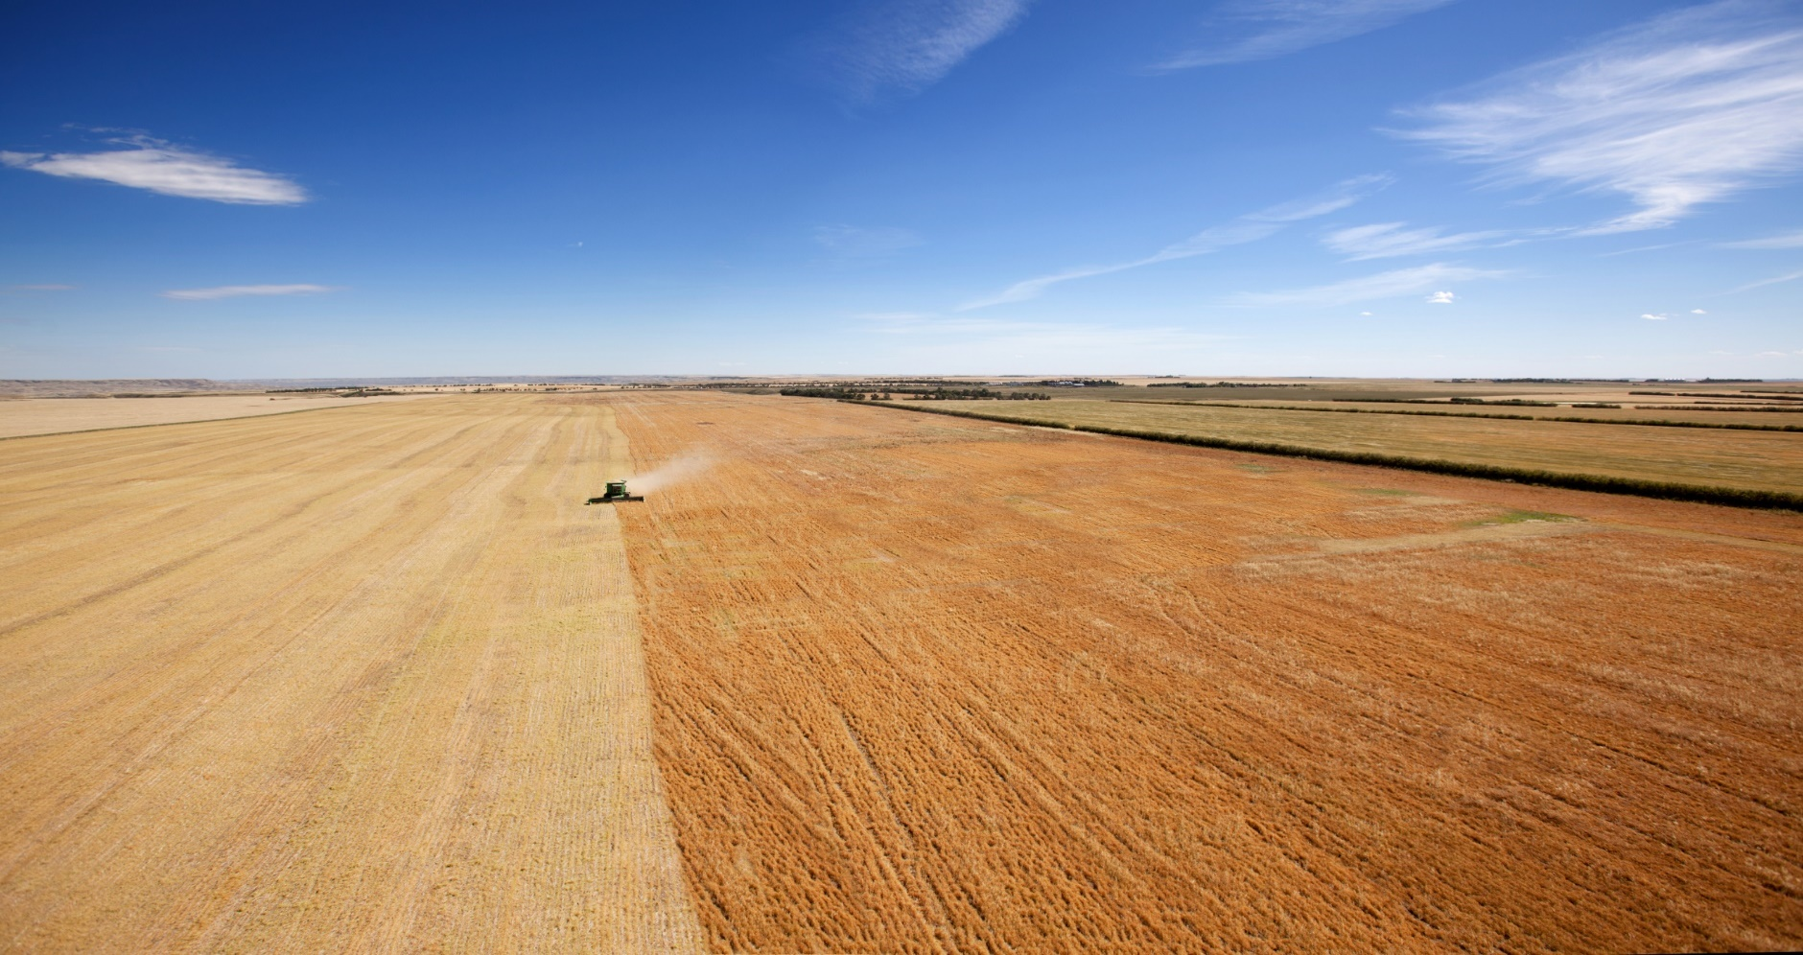

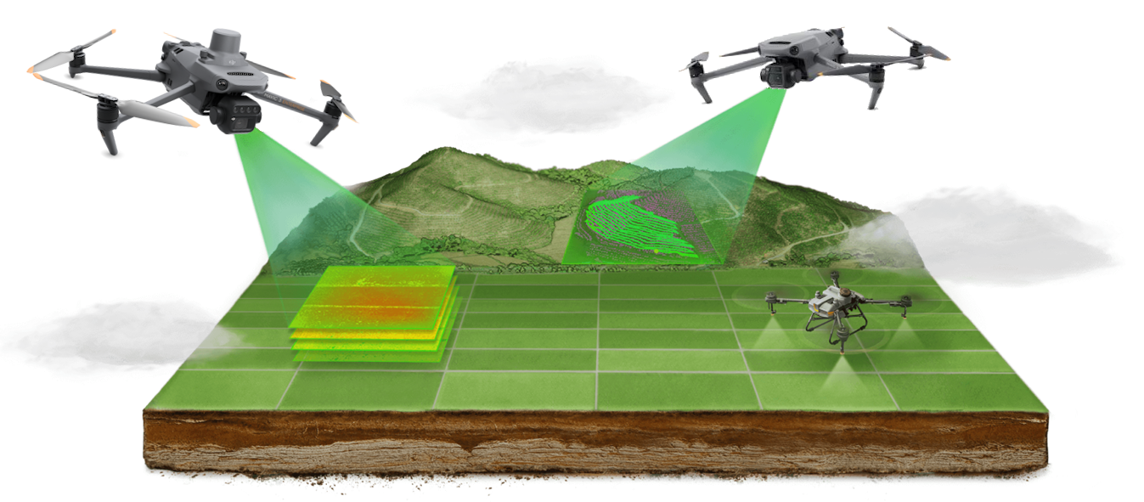

Flights southbound on March 2,  
northbound on March 6. If you want to stay longer, just let us know and we can certainly book it that way if the cost is similar.

Hotel will be in Chandler, Arizona with shuttle bus from the airport and LandView providing transportation to the clinic.

* **Intro to product application by drone**
* **Spray quality & drift**
* **Regulatory issues in aviation & pesticides**
* **Multispectral mapping for prescriptions**
* **Pesticide safety**
* **Flight planning & mission planning**
* **Calibration of application parameters**
* **Hands-on practice designing and  
  executing spraying/spreading missions**

Show Special requires deposit of 50% be made by February 14, 2025, delivery will still include 2 hours with our technicians on-farm or a full day of hands-on training at our shop.

**March 4-5, 2025**

**Arizona**

**LOVE OF AGRICLTURE   
FREE** with every Agras T50  
package, including:

* Airfare
* 4 nights accommodation
* 2 lunches, 2 suppers
* 2 days of training

**Casa Grande, Arizona**

**Drone Spraying Clinic**

**Casa Grande, Arizona**

**March 4-5, 2025**

Day One Morning *Tuesday, March 4*

9:00 a.m. **Welcome & Introductions**Note: We will adjust the schedule based on forecasted weather conditions, with the goal of completing the hands-on-flight portion of the agenda at some point.

9:30 a.m. **Introduction to Product Application by Drone**  
We start with a full Scout-Map-Apply demo.  
The entire workflow without too much detail, but giving participants a quick demonstration of what they will be learning over the next two days. We then provide insight into the current status of drone spraying equipment, from the biggest positive surprises to the negative aspects we have encountered...

11:00 a.m. **Spray Quality & Drift**

We will review foundational principles around nozzle design, spray distribution, spray quality, and off-site drift. These concepts are as important for drone application as for ground sprayers, with unique dynamics. This will include insights gleaned from LandView’s research with the newest generations of Agras drones and spot-spraying of Canada Thistle over the past three seasons. We will show comparisons in spray quality with change in altitude, speed, and nozzle types. There is a careful trade-off between coverage and drift that will require special attention when applying by drone.

**Day One Afternoon *12:00-1:00 lunch supplied***

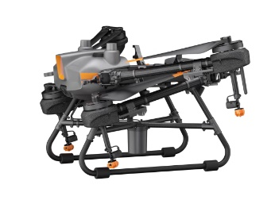

1:00 p.m. **Regulatory Issues: Aviation & Pesticides**

The majority of the drones coming onto the market have a takeoff weight greater than 25 kilograms, therefore requiring a Special Flight Operations Certificate. We will present details of the SFOC process. We will also discuss the current state of pesticide regulations as they pertain to drone application. The punchline is that the Pesticide Management Regulatory Agency does not currently allow any application of regulated pesticides except pursuant to a Research Authorization. This unfortunately includes herbicides, fungicides, and insecticides.

1:30 p.m. **Spray Quality & Drift: continued**

Accurately hitting the target and getting sufficient coverage are crucial factors in getting good efficacy from spray application. We’ll spend another 90 minutes on these important topics. This session will include a live demo of different spray qualities and samples of spray distribution with changing flight parameters.

3:00 p.m. **Flight Planning & Mission Design**

Discussion of the many parameters to be considered when planning a spraying or spreading mission, from water volumes to calibrating the pass width. We will go through the planning interface in the Agras controller, including suggestions on speeds and altitudes.

4:00 p.m. **Outdoor Flight Practice**

Time and weather permitting, we may do some outdoor flying on day one. While you are required to have a Basic Certificate to operate an RPAS, we will assume that you don’t yet have extensive experience. We will have some drills for you to complete with DJI Mini, Mavic, and Matrice-series aircraft. **We conclude for the day at 4:45 pm.**

Day Two Morning *Wednesday, March 5*

9:00 a.m. **Multispectral Mapping for Prescriptions**

We will present a software platform which is particularly straightforward and fast at producing prescription zones based on drone imagery – Pix4Dfields using imagery collected from the Mavic 3 Multispectral or a Micasense multispectral camera. This session will be focused on practical aspects of flight planning and time requirements for all aspects of the workflow.

We will also demonstrate the workflow for creating spraying missions using DJI Terra software as a comparison of different software workflows using multispectral imagery.

10:15 a.m. **Field & Financial Efficiencies, Practical Field Considerations**

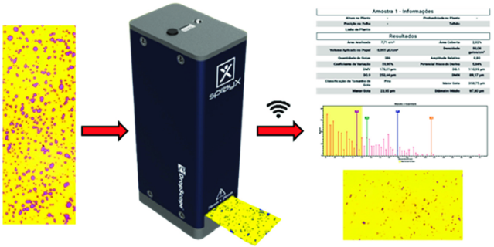We will present information on anticipated field efficiencies – for the T30 and T40, those will be based on experience of larger-scale users and modelling. The actual field efficiency will depend largely on minimizing down-time and non-spraying filled flight time. We’ll discuss the impact of nurse truck placement and swarming behaviour or field-splitting. We’ll also present an analysis of the relative costs of different application methods – including hardware and labour.

11:00 a.m. **Sprayer Calibration**

We will go through all of the aspects of required and recommended calibration processes. This will include flow meter calibration/confirmation, pump calibration, and especially calibration of path width using water-sensitive paper. We will also introduce the DropScope and Swath Gobbler systems for measuring spray quality and coverage width calibration.

Day Two Afternoon *12:00-1:00 lunch supplied*

1:00 p.m. **Achieving Accuracy**

Whether mapping or spraying, getting accurate results from a drone is crucial to success. We will discuss the process for spectral calibration during multispectral mapping missions, the process for improving geolocation accuracy through Real Time Kinematics or Post-Processing Kinematics. We will also review in what practical field situations this might be necessary and/or useful.

2:00 p.m. **Hands-On Practice**

Participants will be working in teams on several missions, including mapping, spraying and spreading operations. This will include both design of the mission and actual execution, including calibration of sprayer/spreader width.

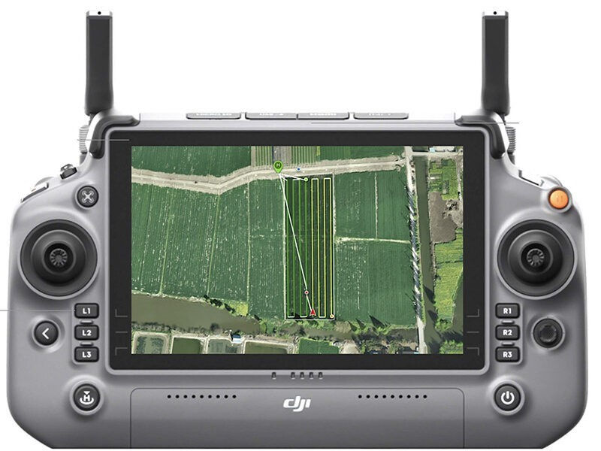By the end of the day, all participants will have had an opportunity to operate the Agras T10 in several modes, including M+ mode (manual plus), which is most commonly used for calibration or manual spot-spraying missions, as well as a route-spraying flight. If weather allows, that will include spraying water on a simulated field area.

All practice flights will be with the Agras T10 since the T50 would require advanced certification through a Special Flight Operations Certificate (SFOC) because they weigh more than 25 kilograms. The operation of all of the aircraft is very similar, so the practice will be relevant regardless of the aircraft participants will ultimately be operating.

Please dress for the weather to get the most out of this hands-on session.

4:45 p.m. **Drone Spraying** **Clinic concludes, thank you for joining us**

**www.landview.com**





**Advanced Pilot Bundle**

If you do want to get your Advanced Certificate, we have partnered with Coastal Drone to provide their Advanced Pilot Bundle, which includes over 20 hours of online instruction, preparation for the Flight Review, and the in-person Flight Review itself.  In other words, the bundle consists of everything you’ll need to get your Advanced Certificate from Transport Canada.  We discount their bundle for anyone attending any of our other training. It normally retails at $590, but we offer a $190 discount in combo with either the Ag Drone School or the Spraying Clinic.

**Basic Certificate Crash Course**

You do not need an SFOC to operate an Agras T10 in Class G airspace well away from certified airports and bystanders. That means that you can fly our Agras T10’s at the school. If you don’t already have the Basic Certificate, just let us know that you’d like a login to our 3-hour online crash course – we will not charge you anything extra for that.

**Do you plan on operating a spraying drone with a takeoff weight of 25kg or more?**

Drones above 25 kg (Agras T20, T30 or T40 or similar) require a **Special Flight Operations Certificate (SFOC)** to operate.  The owner of the drone will typically be the one applying for an SFOC through a process that will usually take   
3-12 weeks to complete.  Transport Canada will review your SFOC application outlining your planned risk-mitigation measures and then provide you with a letter that outlines your requirements and restrictions when operating the drone.  Transport Canada will typically require that at least one person on the flight team named in the SFOC application hold an Advanced Certificate.  We will provide a complete outline of this process at the clinic.

In a nutshell, here’s the sequence of events for acquiring an SFOC if you don’t already have an Advanced Certificate  
(in-person aspects in green). If you are just interested in spraying in the future, then we suggest you just come to the spraying clinic first. We expect the regulations will change in late 2025 (more on that at the clinic), so if you are serious about operating a large drone during the 2025 crop year, we suggest you get started on the process right, because we could complete your Flight Review one morning or evening when we are at the clinic.

**Register at LandView.com  
or call (780) 448-7445**